Date | 28.09.2026
Team ID | SWTID-2026-6482
Project Name | Auto Ticket Classification using Flow Designer

Ideation phase-I

3. Empathy Mapping

3.1 What is Empathy Mapping?
Empathy Mapping is used to understand user behaviors, pain points, and needs. We mapped 3 key personas for Auto Ticket Classification project using Says, Thinks, Does, Feels framework.

3.2 Overview of All Personas
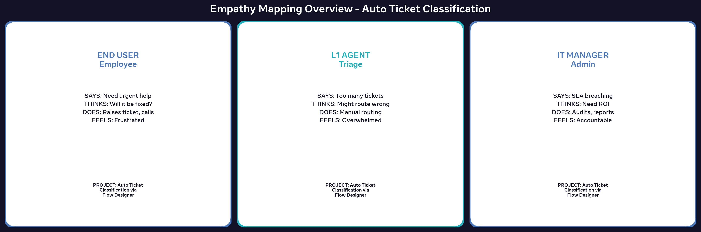

3.3 Persona 1: End User (Employee)
SAYS: "My ticket is urgent but no one responded for 2 days"
THINKS: "Will my ticket go to right team? Why fill so many fields?"
DOES: Writes long descriptions, uploads screenshots, calls helpdesk, creates duplicate tickets
FEELS: Frustrated, blocked, anxious, helpless
PAIN POINTS: Delay in resolution, no transparency, work blocked
GAINS NEEDED: Instant acknowledgement, faster resolution, auto KB suggestions
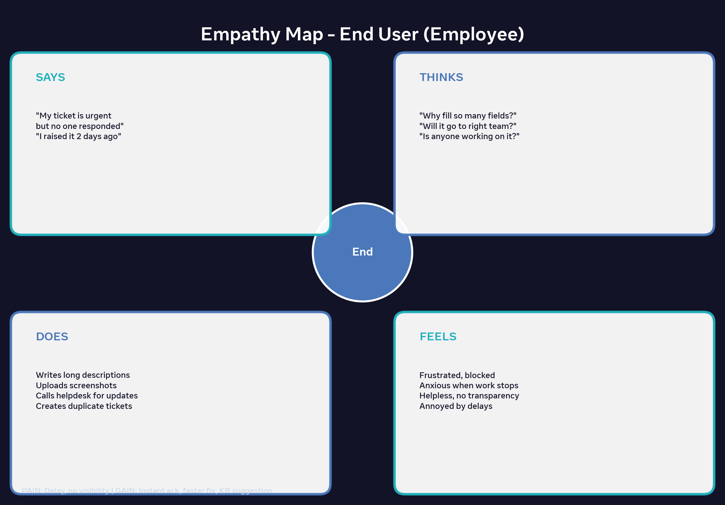

3.4 Persona 2: L1 Support Agent
SAYS: "I have 200 tickets to triage today", "Description is unclear"
THINKS: "This looks like network but user said hardware - I might route wrong"
DOES: Reads each ticket, manually sets Category, Assignment Group, follows up
FEELS: Overwhelmed, pressured, bored by repetitive work, fear of blame
PAIN POINTS: Repetitive manual work, blame for misrouting, high queue
GAINS NEEDED: AI does first-level classification, only handle exceptions/low confidence tickets
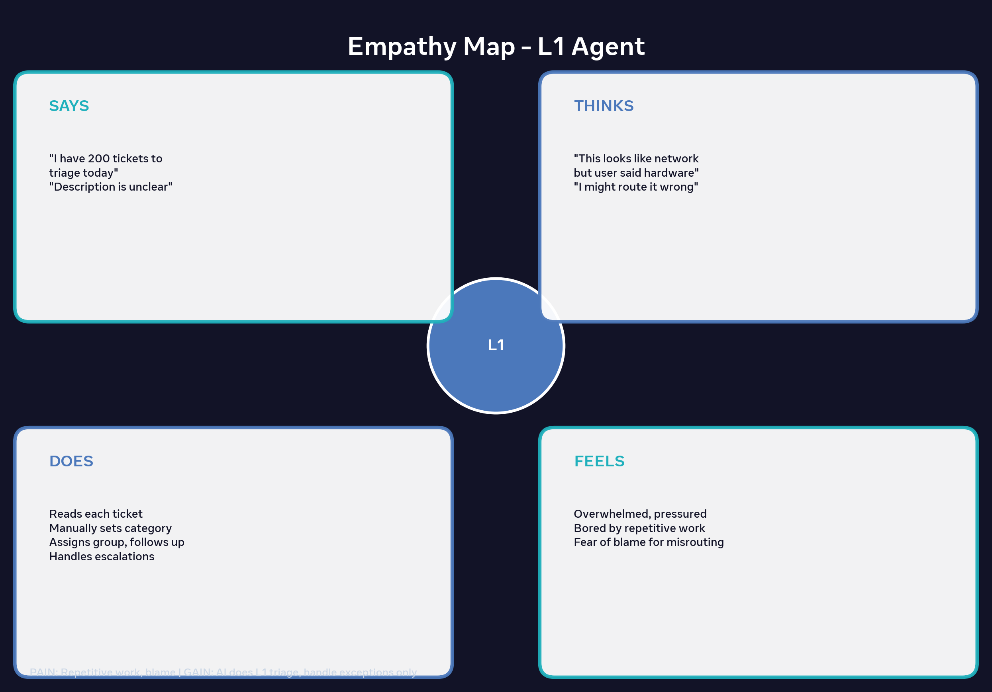

3.5 Persona 3: IT Manager / Admin
SAYS: "SLA breach is 18%, we need to cut MTTR", "Show ROI on automation"
THINKS: "How to optimize resources? Can AI cut L1 cost? How to upskill team?"
DOES: Checks SLA reports, audits misrouted tickets, trains agents, presents KPIs
FEELS: Accountable for KPIs, wants innovation, stressed about cost & quality
PAIN POINTS: High operational cost, lack of skilled L1 agents, audit pressure
GAINS NEEDED: Dashboard with accuracy metrics, self-learning system, cost reduction
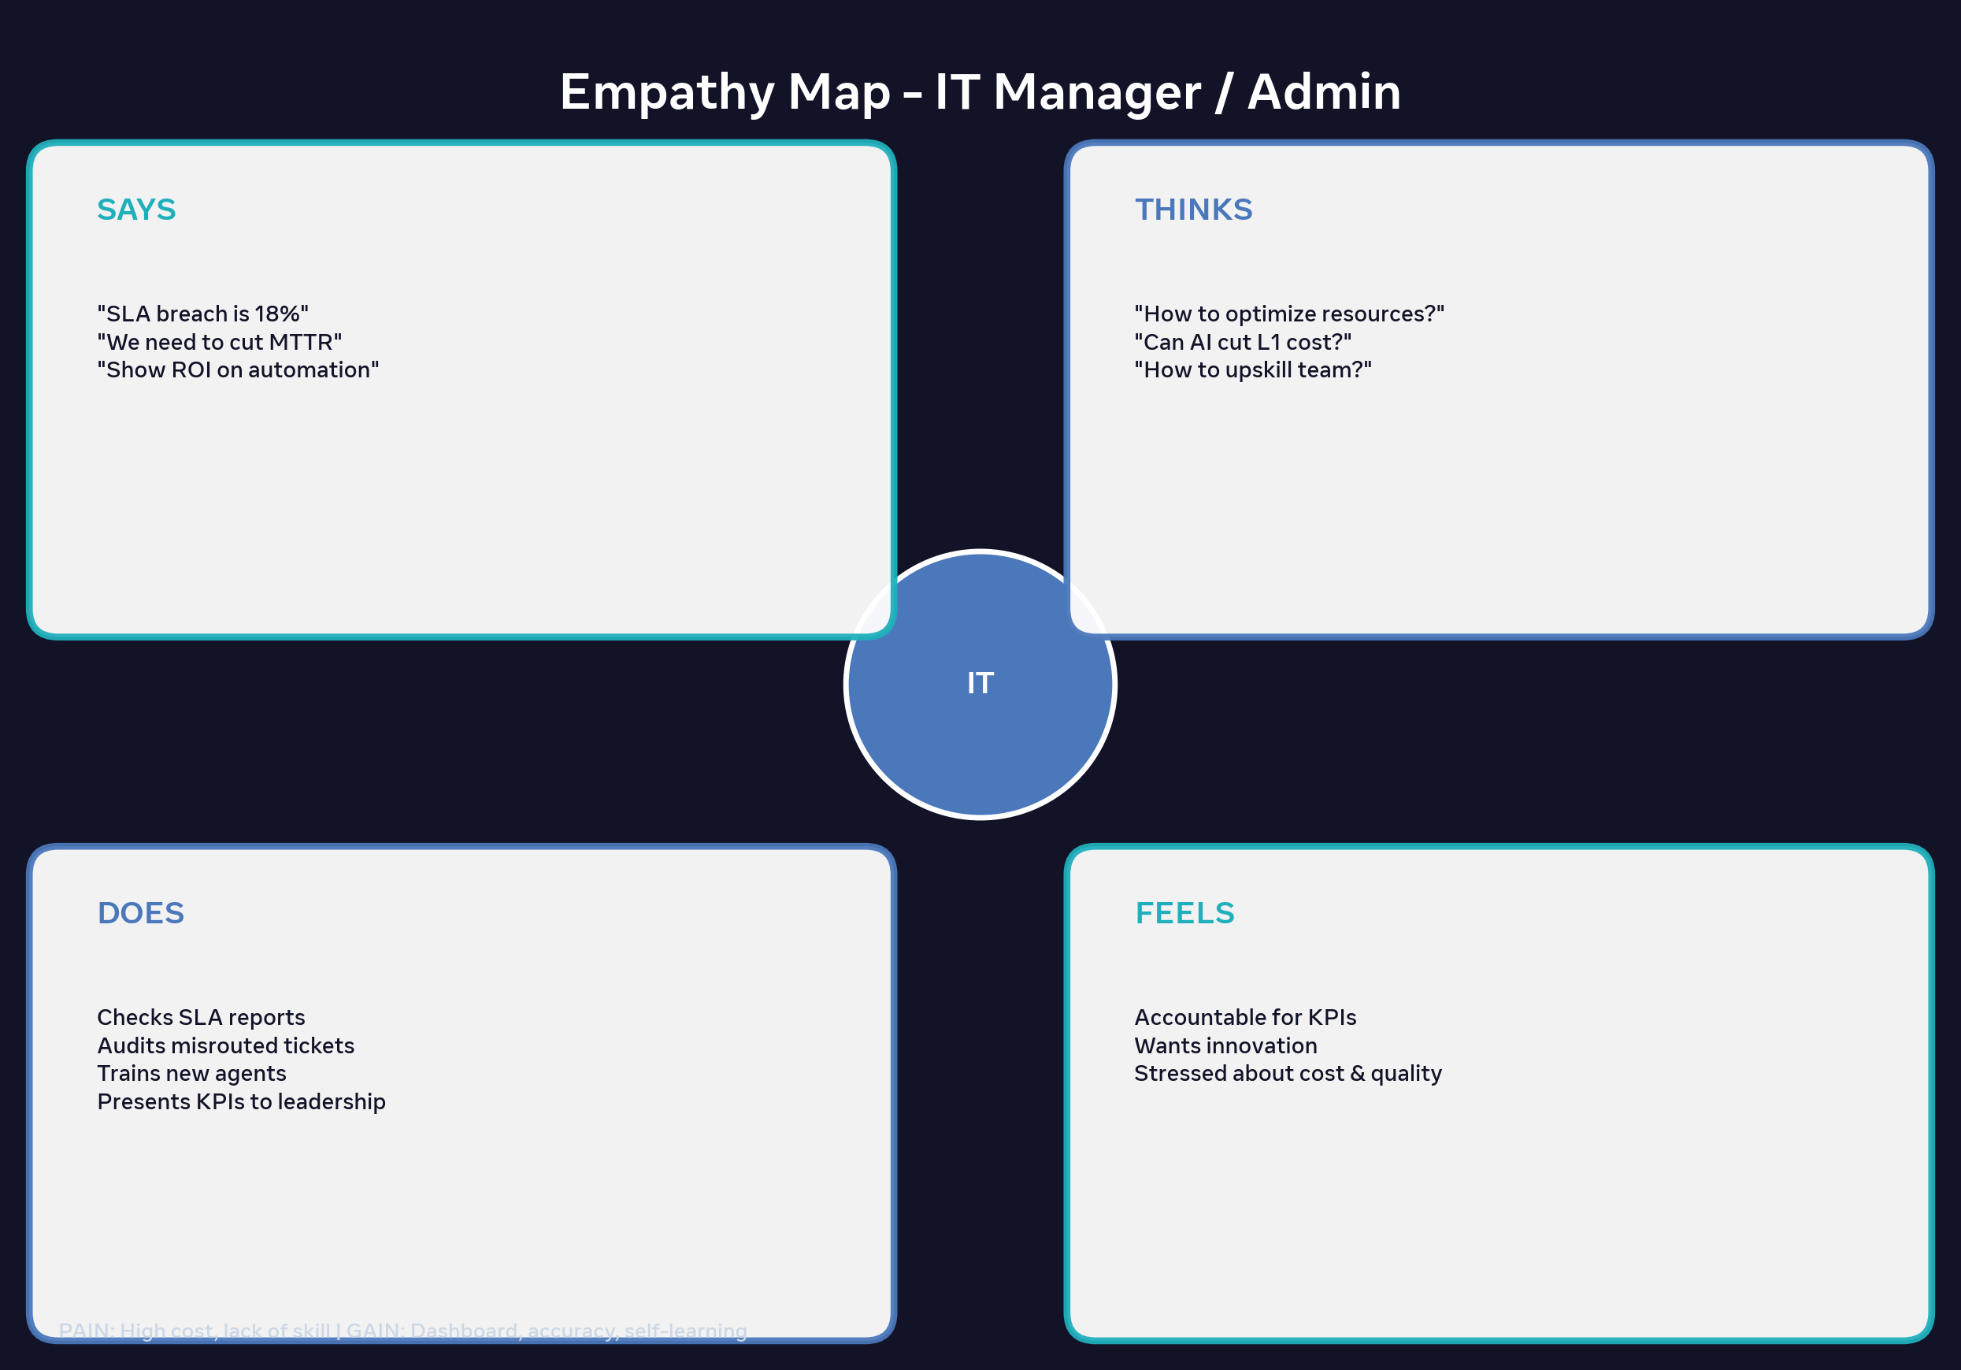

3.6 Key Insights
Insight 1: Users don't want to fill Category fields - understand natural language.
Insight 2: Agents want augmentation not replacement - handle only low-confidence tickets.
Insight 3: Manager wants measurable ROI - misrouting % and MTTR reduction.
Design Decision: Our MVP uses Flow Designer + ML with confidence-based fallback to address all 3 personas.

